**Box-shadow**

<http://www.css3.info/preview/box-shadow/>

**Reading**

The box-shadow property allows designers to easily implement multiple drop shadows (outer or inner) on box elements, specifying values for color, size, blur and offset.

Browser support is growing of late with Mozilla (Firefox), Webkit (Safari/Chrome/Konqueror), Opera and the IE9 Platform Preview all offering a decent implementation of the spec, although Mozilla and Webkit still require their respective -moz- and -webkit- prefixes (note Mozilla Firefox 4.0+ no longer requires the -moz- prefix).

Here’s a basic example:

#example1 {

box-shadow: 10px 10px 5px #888;

}

But for the moment, as with many other ‘experimental’ CSS3 properties, you’ll need to use the following prefixes to support Mozilla and Webkit:

#example1 {

-moz-box-shadow: 10px 10px 5px #888;

-webkit-box-shadow: 10px 10px 5px #888;

box-shadow: 10px 10px 5px #888;

}

### How it Works

The box-shadow property can accept a comma-separated list of shadows, each defined by 2-4 length values (specifying in order the horizontal offset, vertical offset, optional blur distance and optional spread distance of the shadow), an optional color value and an optional ‘inset‘ keyword (to create an inner shadow, rather than the default outer shadow).

The Syntax:

**box-shadow:** none | <shadow> [ , <shadow> ]*

*<shadow> = inset? && [ <length>{2,4} && <color>? ]*

##### Examples:

box-shadow: 10px 10px;

box-shadow: 10px 10px 5px #888;

box-shadow: inset 2px 2px 2px 2px black;

box-shadow: 10px 10px #888, -10px -10px #f4f4f4, 0px 0px 5px 5px #cc6600;

Let’s first look at how to create a basic outer shadow, before going on to look at the inset keyword, layering multiple shadows and how to spice up your shadows with RGBa colors(?).

**Creating a basic drop shadow**

By default, shadows are drawn on the outside of elements. According to the specification;

The first step is to define the shape of the shadow by specifying 2-4 length values.

The first value defines the horizontal offset of the shadow, with a positive value offseting the shadow to the right of the element, and a negative value to the left.

The second value defines the vertifical offset of the shadow, with a positive value offsetting the shadow from the bottom of the element, and a negative value from the top.

If supplied, an optional third value defines the blur distance of the shadow. Only positive values are allowed, and the larger the value, the more the shadow’s edge is blurred. The specification does not include an exact algorithm for how the blur distance should be calculated:

An optional fourth value can be supplied to define the spread distance of the shadow. A positive value will cause the shadow shape to expand in all directions, while a negative value will cause the shadow shape to contract. The specification goes into much greater detail on how the shadow shape is calculated.

The diagram below (taken from the W3C Backgrounds and Borders Candidate Recommendation) offers a good example of the effects of spread and blur on the shadow:

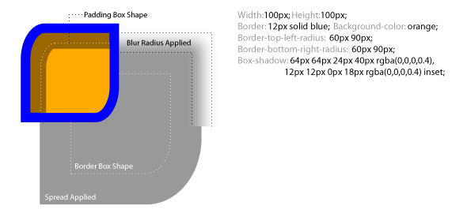

An optional color value can also be supplied, directly after the 2-4 length values, to define the shadow’s color. If not supplied, a UA-chosen default should be applied, however, whilst in Firefox/Opera/IE9 the default color is black, in Safari/Chrome (webkit) no shadow is visible unless a color is specified.

**Questions**

What does box-shadow property allow?

What prefix require Mozilla?

What prefix require Webkit?

Where are drawn shadows by default?

What does the first value define?

What does the second value define?

What does the third value define?

What does the fourth value define?

**Vocabulary**

outer: exterior, externo

inner: interior, interno

blur: borroso

offset: desplazamiento

spice up: dar vida